G&V Assignment 2 Screenshots Victoria Yong 1004455

Model1.skel

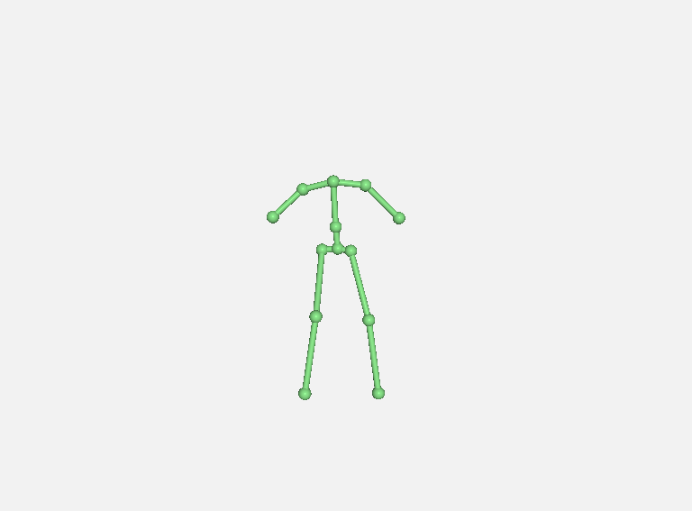

Model2.skel

Model3.skel

Model4.skel

